**Objective Answers**

**Q1) List the different types of columns in table “ball_by_ball” (using information_schema) ?**

Ans)

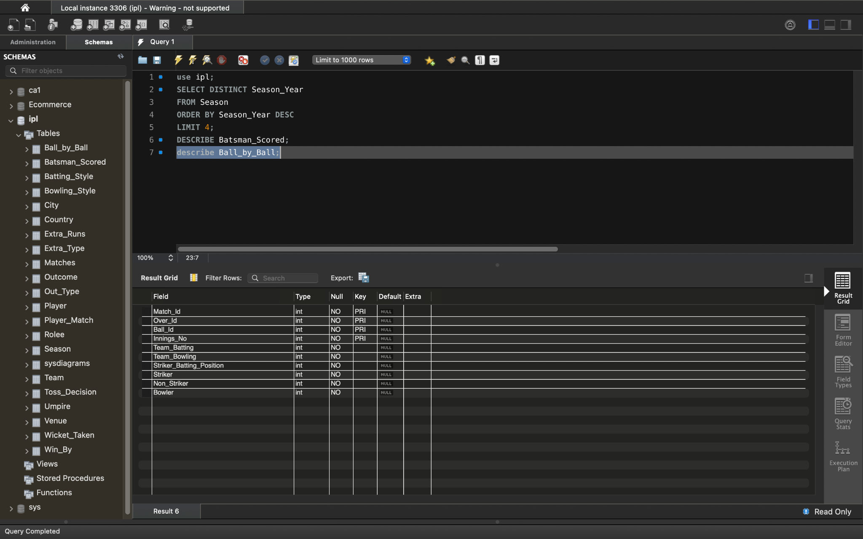

**Q2) What is the total number of runs scored in 1st season by RCB (bonus : also include the extra runs using the extra runs table) ?**

Ans) The total number of runs scored in 1st season by RCB is 1983.

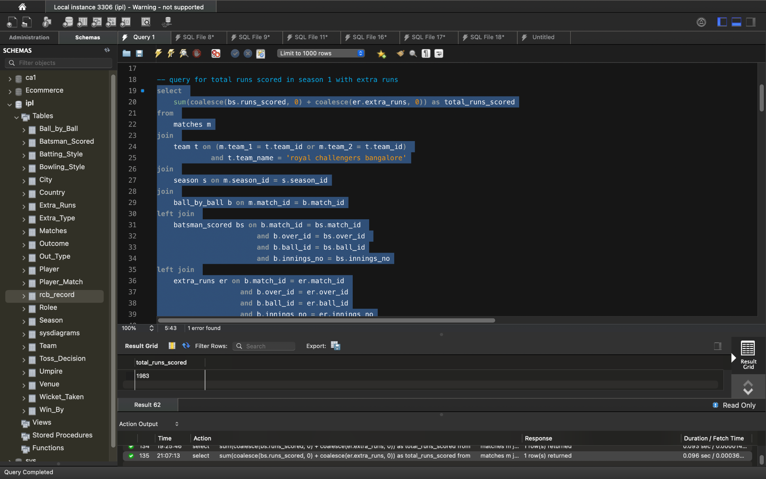

**Q3) How many players were more than the age of 25 during season 2 ?**

Ans) There are 101 players more than age 25 during season 2.

**Q-4 )How many matches did RCB win in season 1 ?**

Ans-4) There are 4 matches won by RCB.

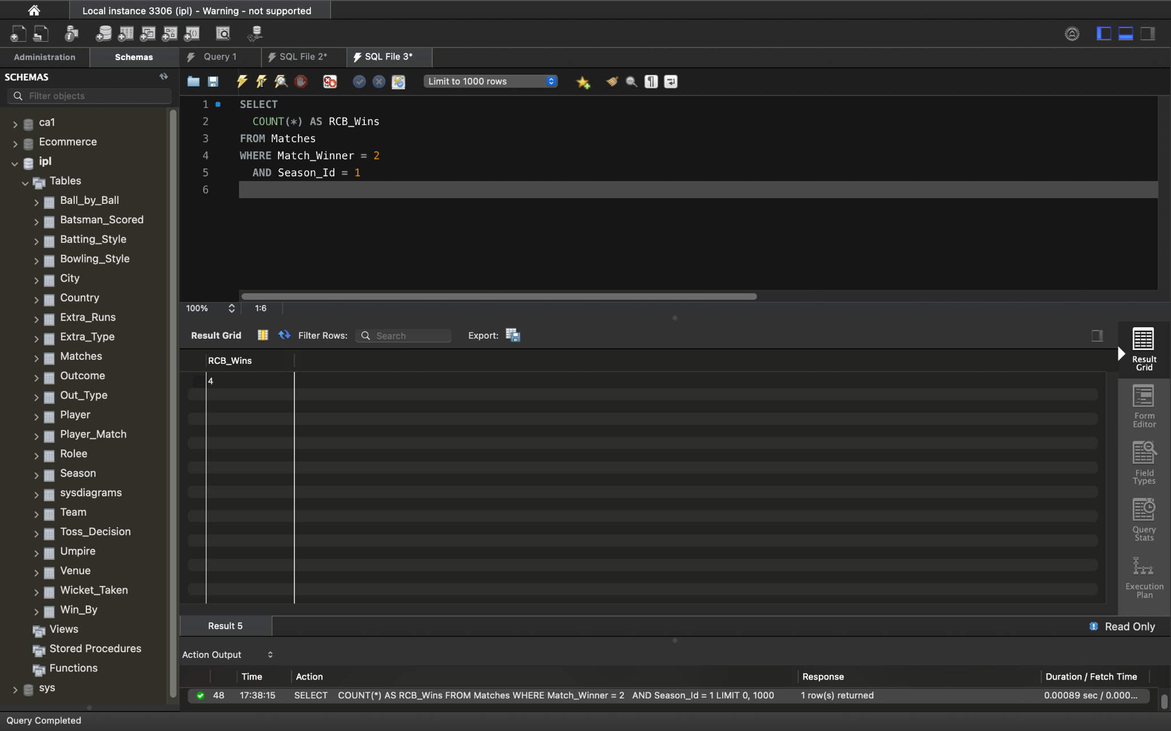

SELECT

COUNT(*) AS RCB_Wins

FROM Matches

WHERE Match_Winner = 2

AND Season_Id = 1

Where season_id 1 is the first season occurred in season_year 2008 and Match_Winner 2 is the Team_id that represents team name ‘Royal Challengers Bangalore’

**Q-5) List top 10 players according to their strike rate in the last 4 seasons ?**

Ans) 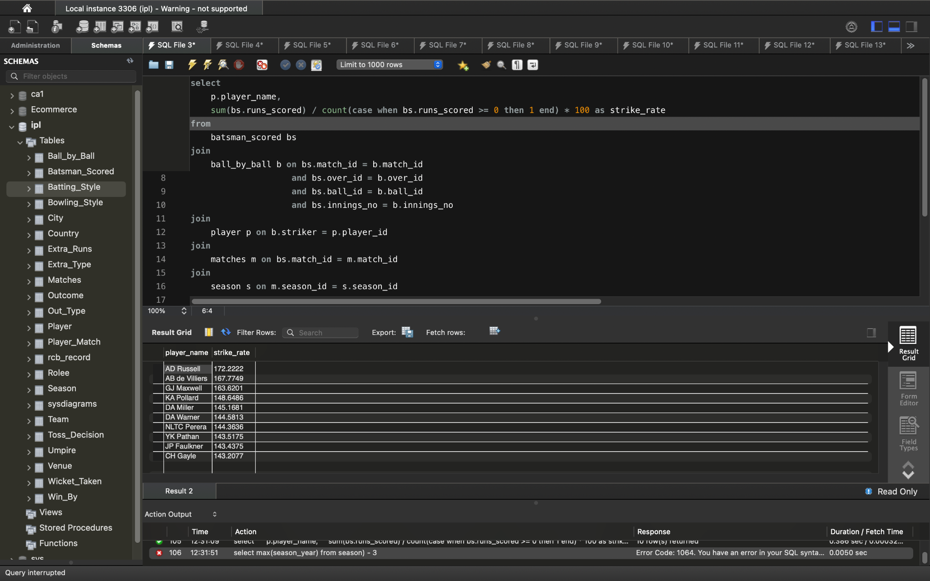

**Q6) What is the average runs scored by each batsman considering all the seasons?**

Ans)

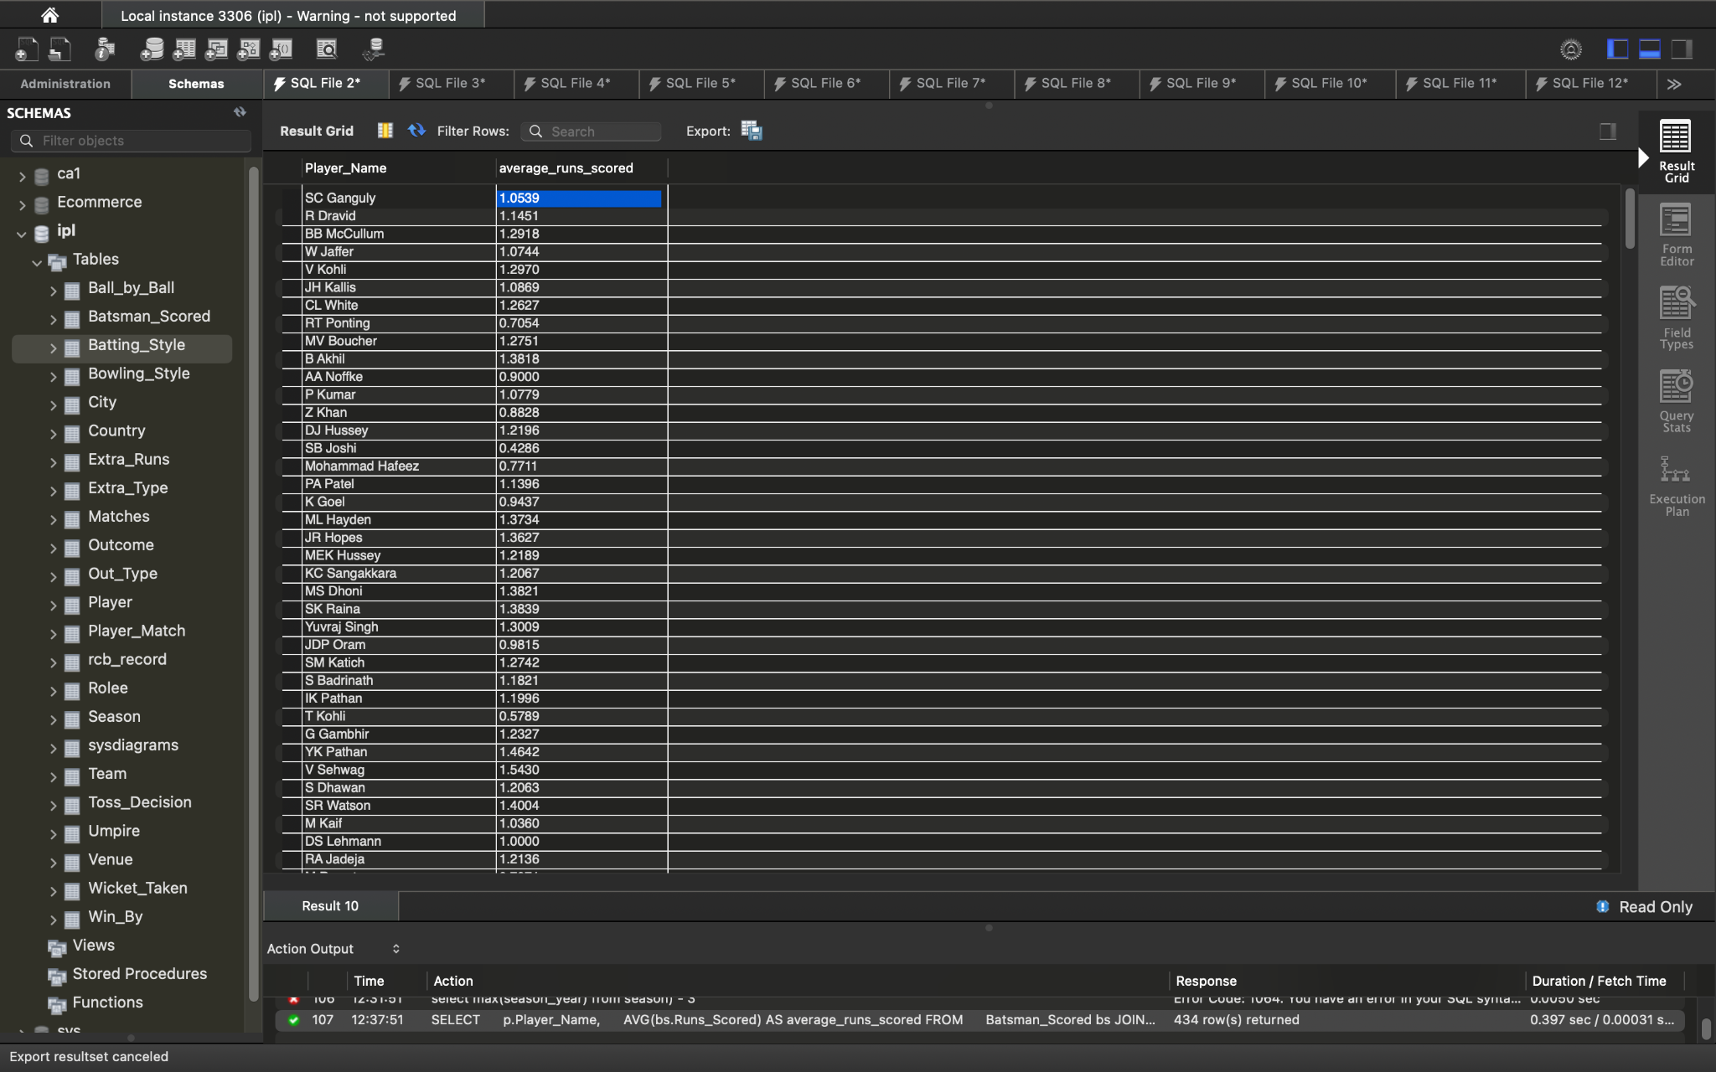

**Q7) What are the average wickets taken by each bowler considering all the seasons?**

Ans)

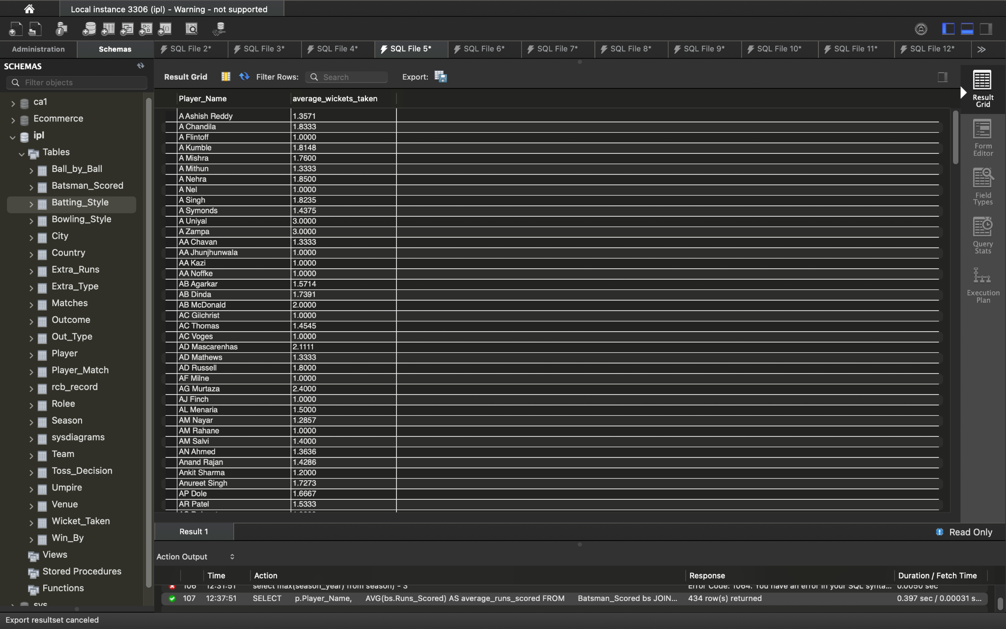

**Q8) List all the players who have average runs scored greater than overall average and who have taken wickets greater than overall average?**

Ans) 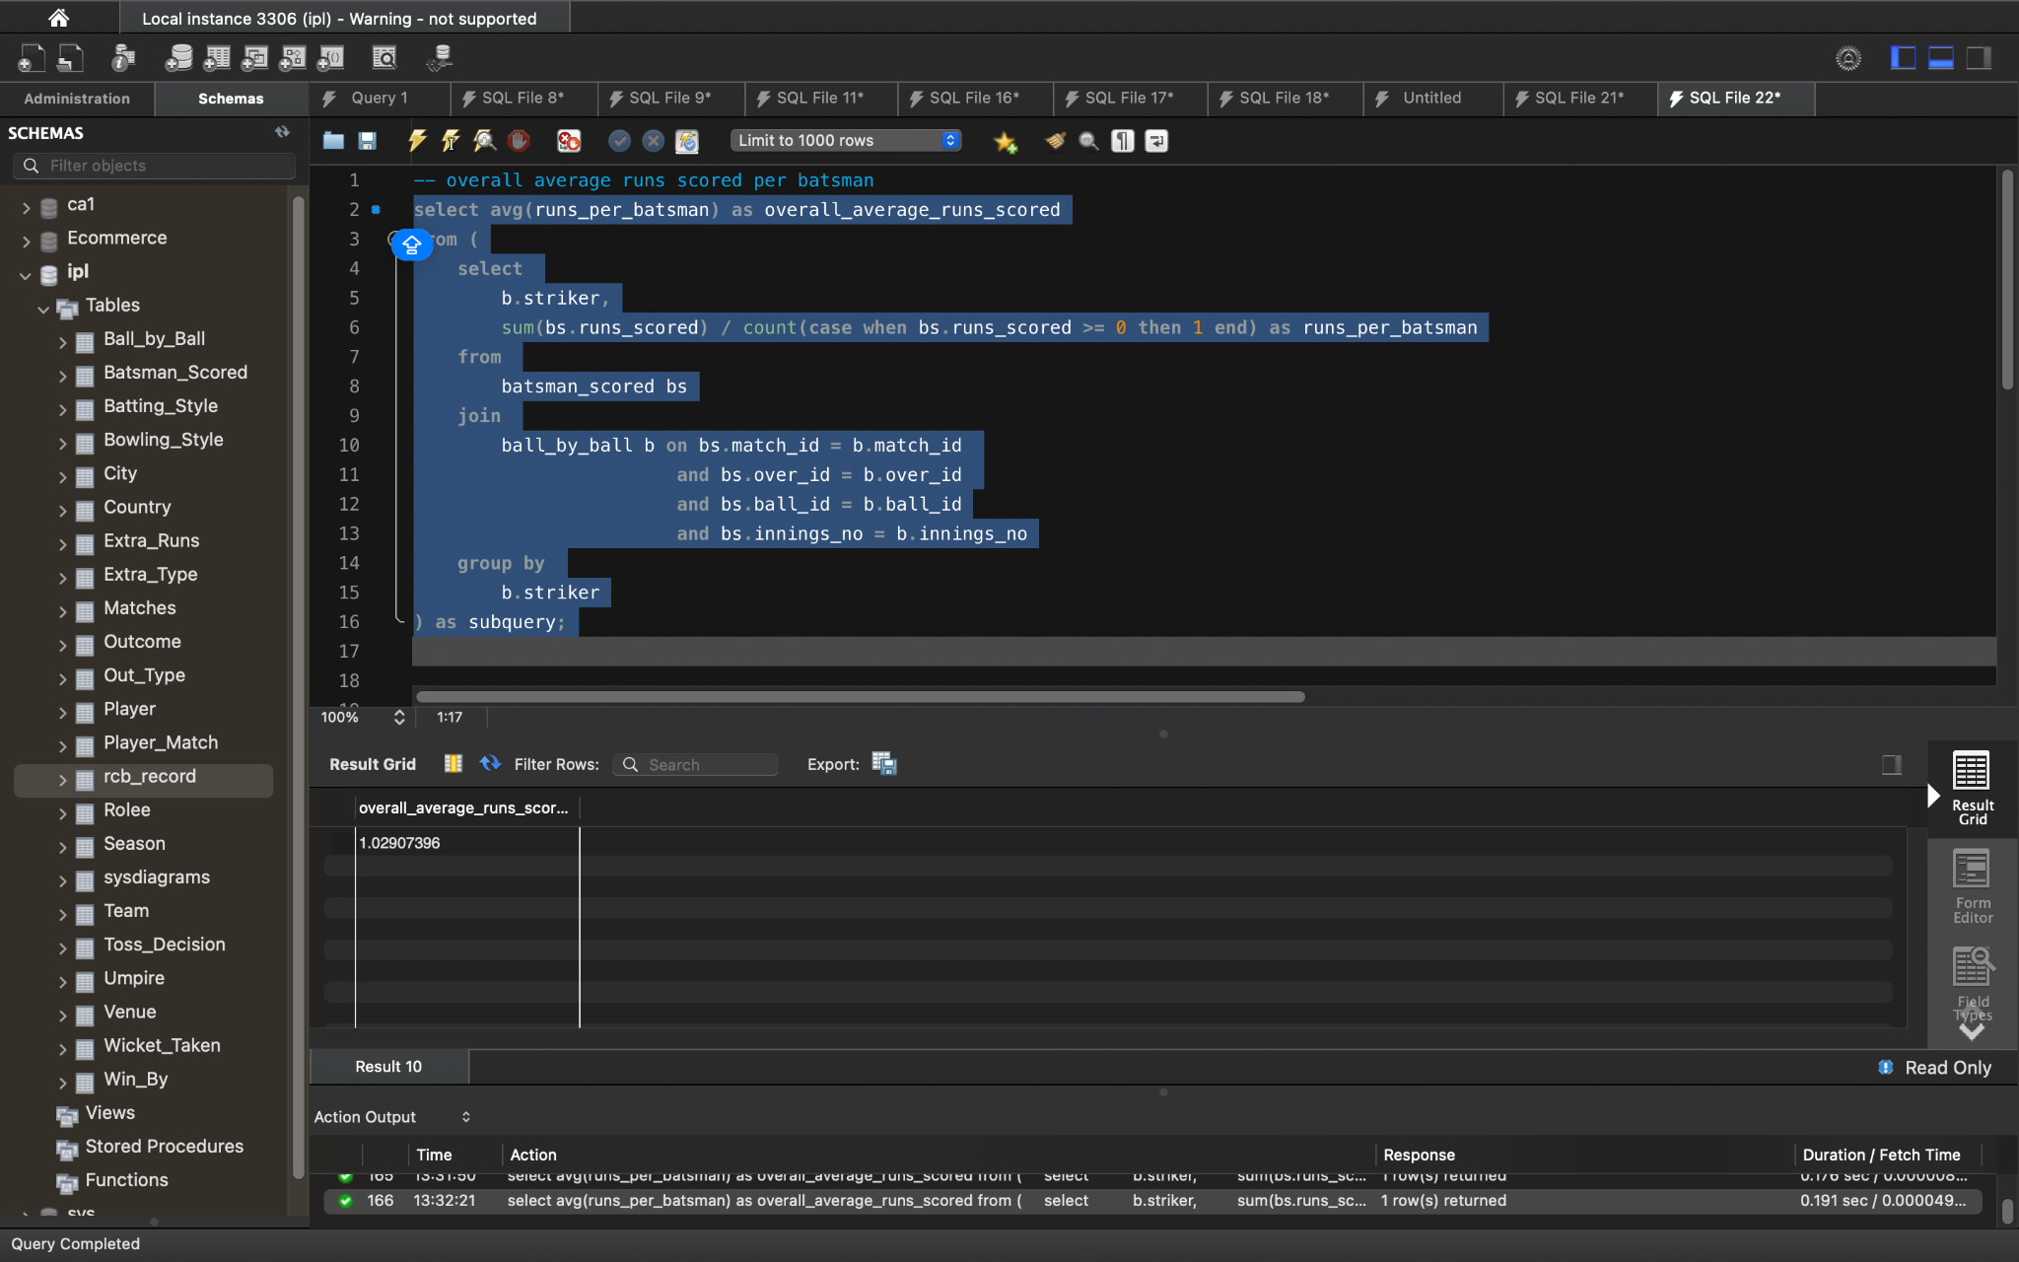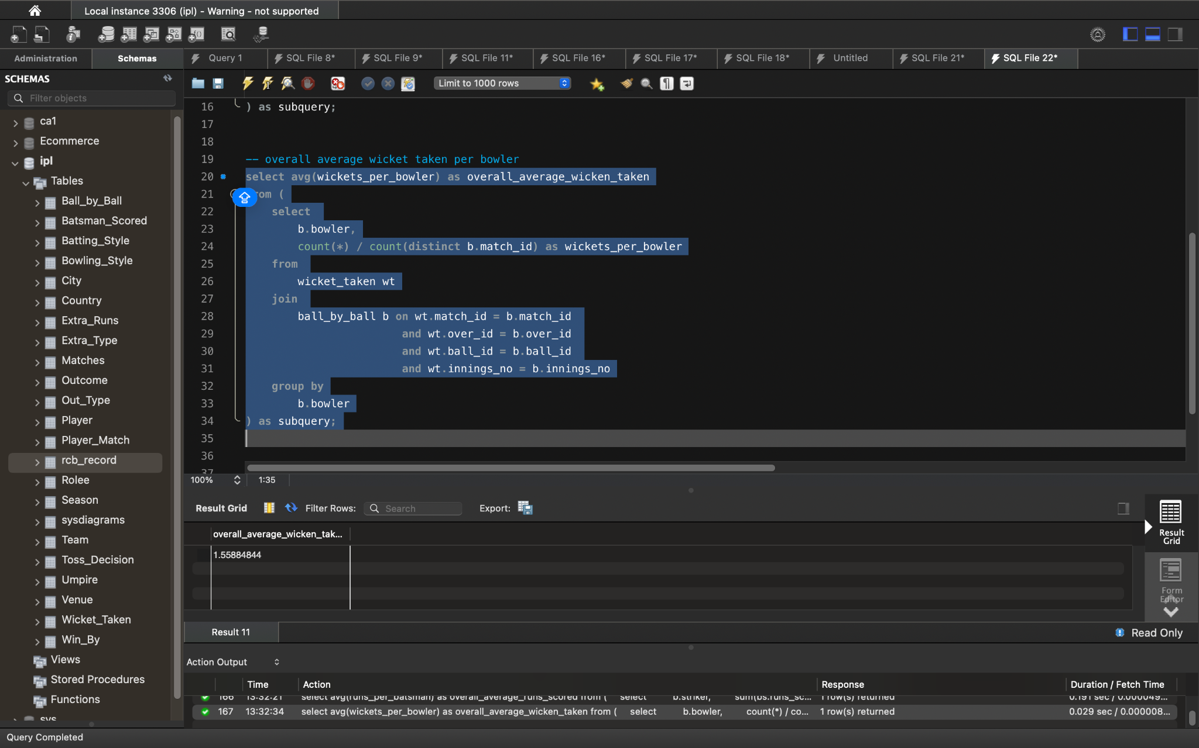

**Q9) Create a table rcb_record table that shows wins and losses of RCB in an individual venue ?**

Ans) 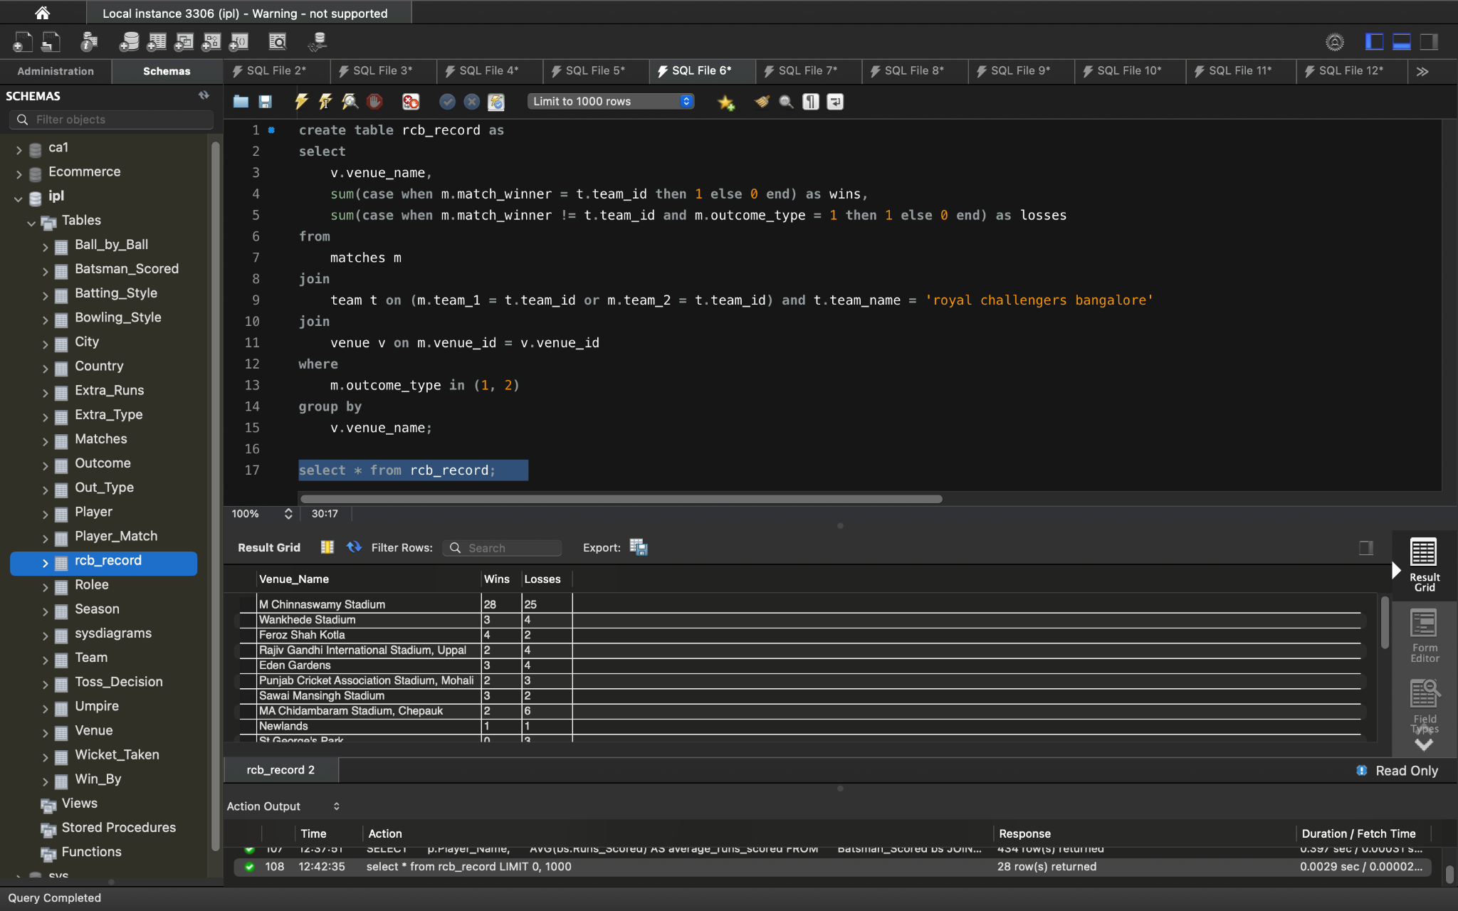

**Q10) What is the impact of bowling style on wickets taken ?**

Ans) 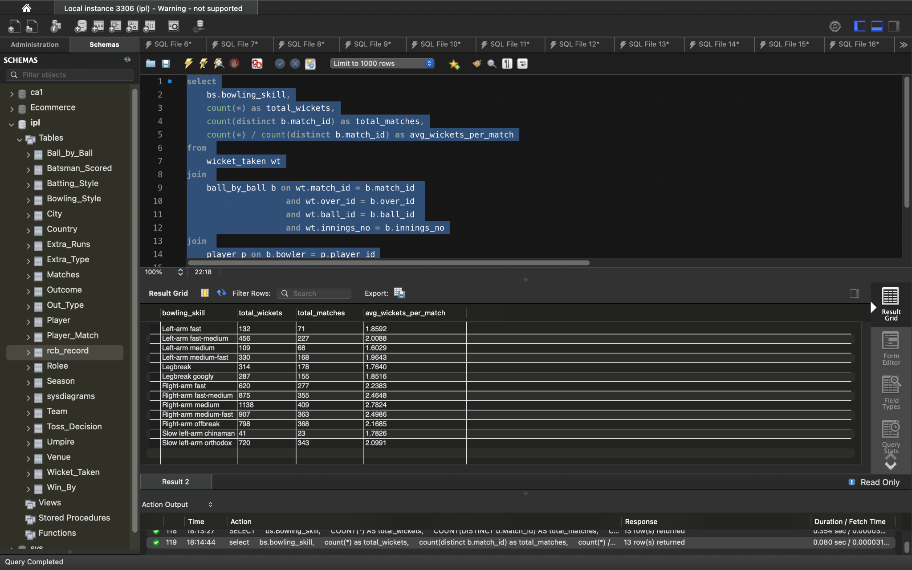

**Joins**:

* We join Wicket_Taken with Ball_by_Ball to connect wickets with the bowler for each ball
* Then join with Player to get the bowler's bowling skill ID and further join with Bowling_Style to get the actual bowling style description.

**Grouping and Aggregation:**

* We group the results by Bowling_skill.
* We calculate:
  + total_wickets: The total number of wickets taken for each bowling style
  + total_matches: The total number of distinct matches where bowlers of that style have taken wickets
  + avg_wickets_per_match: The average number of wickets taken per match for each bowling style

**Q11) Write the sql query to provide a status of whether the performance of the team is better than the previous year performance on the basis of number of runs scored by the team in the season and number of wickets taken ?**

Ans) 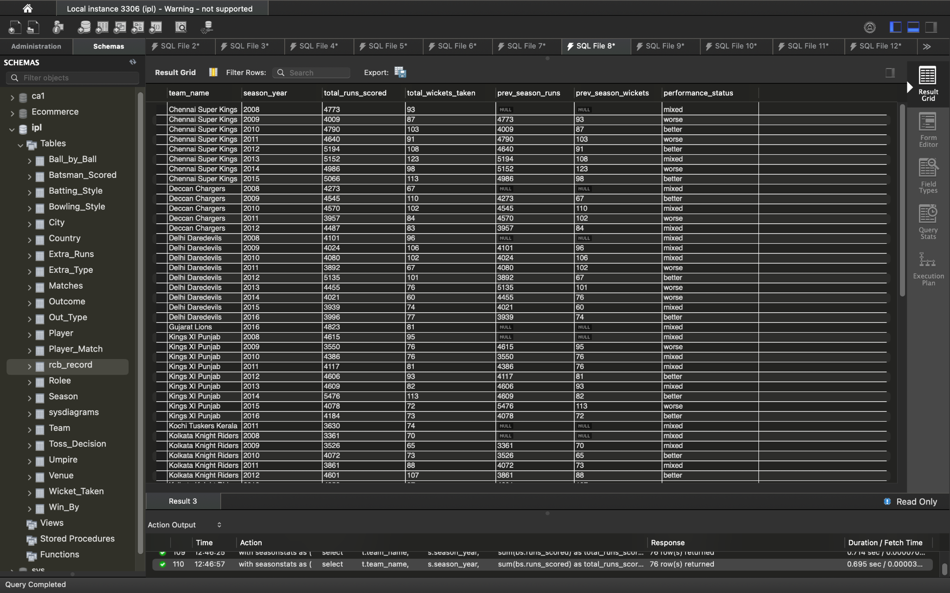

**Q12) Can you derive more KPIs for the team strategy if possible?**

Ans) **Potential KPIs for Team Strategy Analysis**

**Batting-focused KPIs**

* **Boundary Percentage:** The percentage of runs scored through boundaries (fours and sixes). This can indicate a team's aggression and intent.
* **Dot Ball Percentage:** The percentage of balls faced where no runs are scored. This can reveal a team's ability to rotate strike and build pressure.
* **Run Rate in Powerplay:** The run rate achieved in the first six overs. This is crucial for setting the tone for the innings.
* **Run Rate in Death Overs:** The run rate in the final overs (typically 16-20). This shows a team's ability to finish strong or defend a total.
* **Average Partnership:** The average number of runs scored per partnership. This can reflect a team's ability to build partnerships and consistency in the batting order.

**Bowling-focused KPIs**

* **Economy Rate:** The average number of runs conceded per over. This is a fundamental measure of a bowler's or team's bowling performance
* **Strike Rate (Bowling):** The average number of balls bowled per wicket taken
* **Dot Ball Percentage (Bowling):** The percentage of balls bowled where no runs are scored
* **Wickets in Powerplay:** The number of wickets taken in the first six overs
* **Wickets in Death Overs:** The number of wickets taken in the final overs

**Fielding-focused KPIs**

* **Catch Success Rate:** The percentage of catches taken out of the total chances offered.
* **Run-outs Inflicted:** The number of run-outs caused by the fielding team

**Other Strategic KPIs**

* **Win Percentage when Batting First/Second:** This can indicate a team's preference and success rate in different scenarios
* **Net Run Rate (NRR)**: A crucial metric for tie-breakers, calculated based on the average runs scored and conceded per over throughout the season.
* **Success Rate Chasing High Totals:** The percentage of successful chases when the target is above a certain threshold (e.g., 180+).
* **Success Rate Defending Low Totals:** The percentage of successful defenses when the team sets a target below a certain threshold (e.g., 150-).

**Q13) Using SQL, write a query to find out average wickets taken by each bowler in each venue. Also rank the gender according to the average value ?**

Ans) 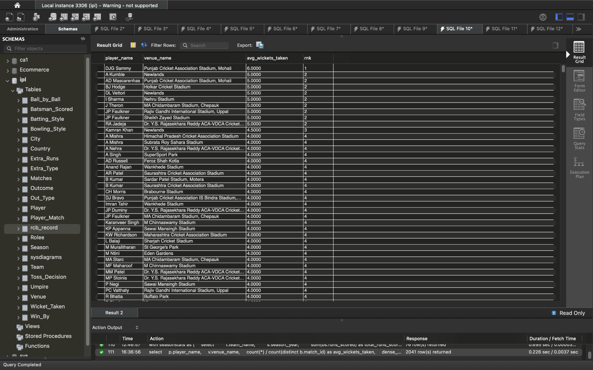

**Q14) Which of the given players have consistently performed well in past seasons? (will you use any visualization to solve the problem) ?**

Ans) players list are same as answer 2 from subjective questions.

**Q15) Are there players whose performance is more suited to specific venues or conditions? (how would you present this using charts?)**

Ans) 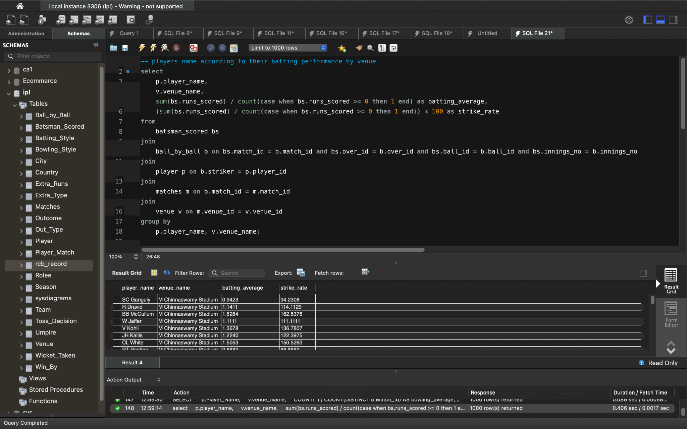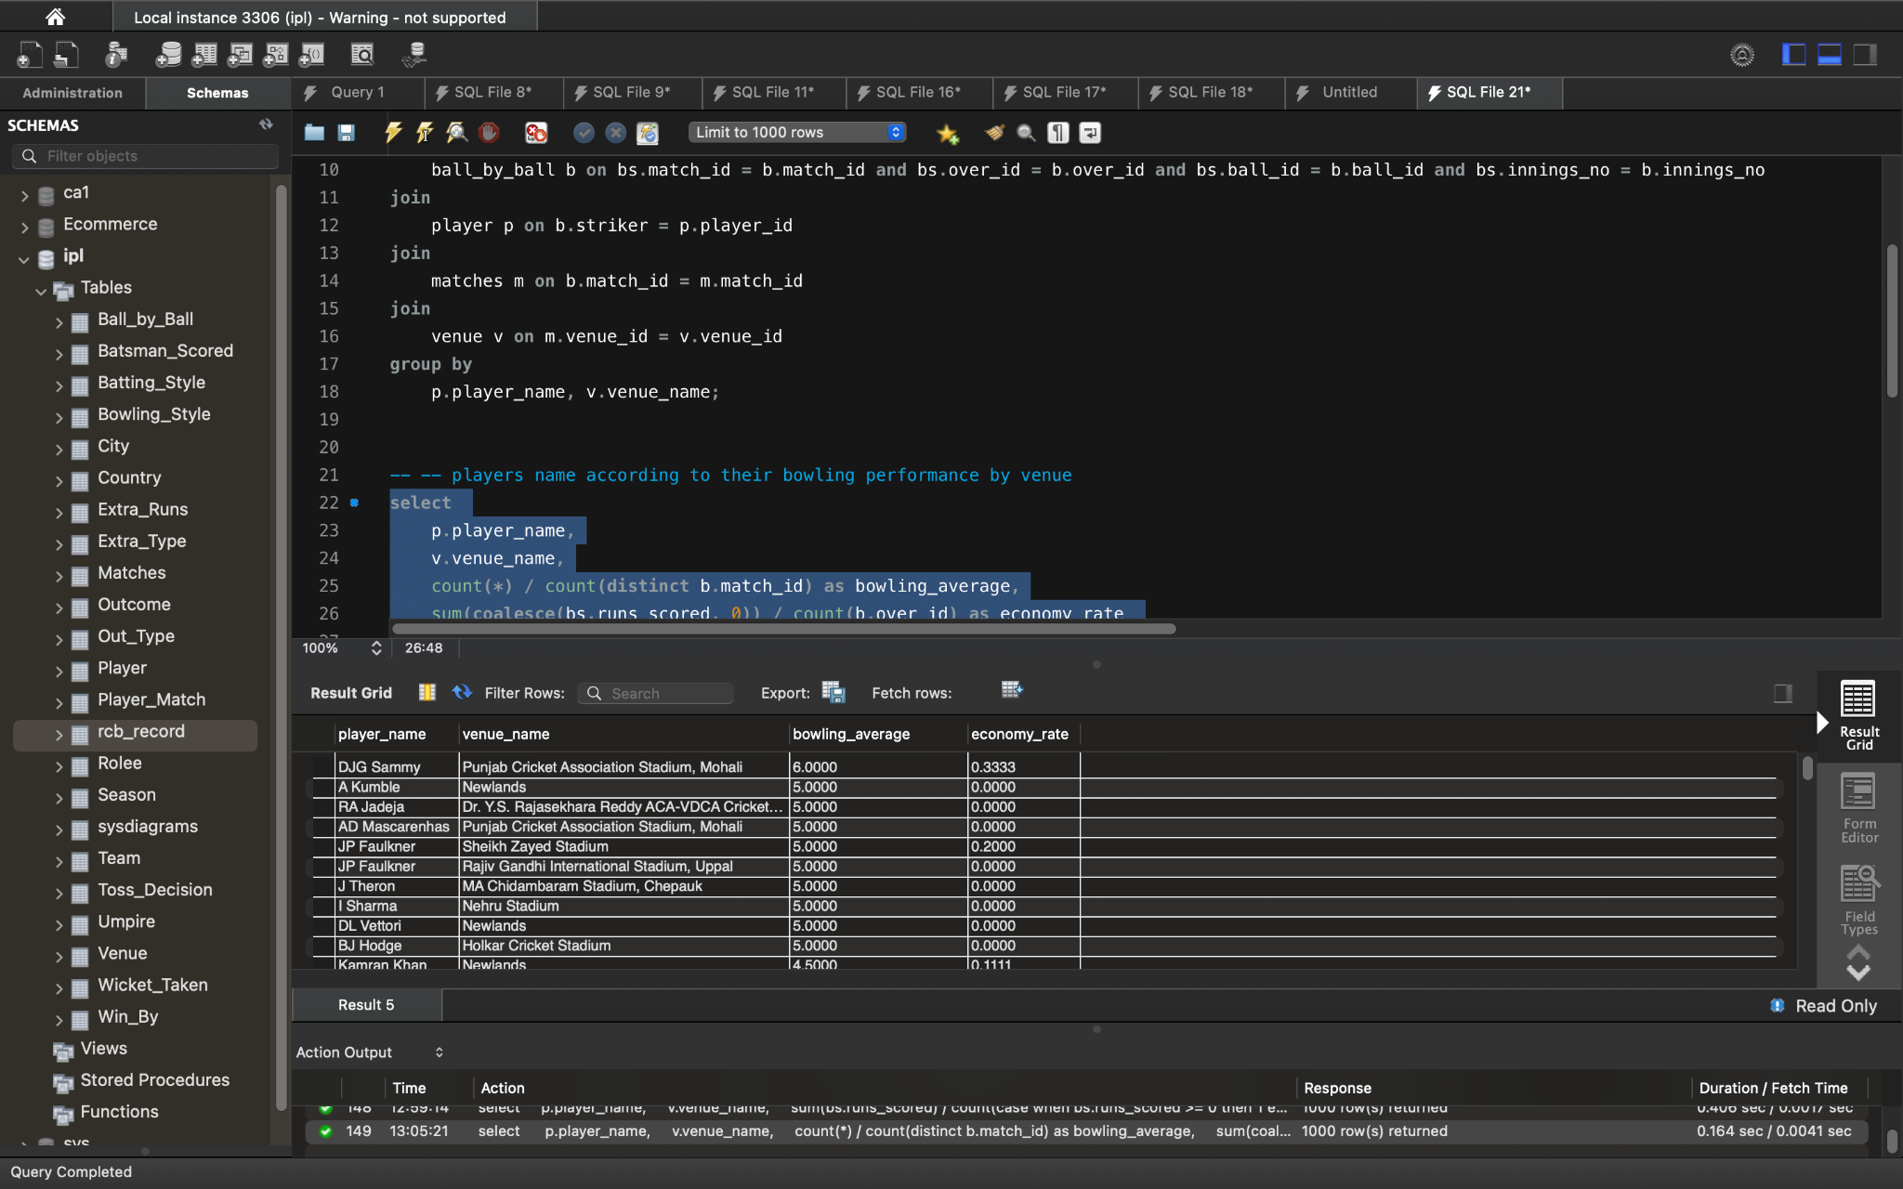

**Heatmaps:**

* Create heat maps where:
  + Rows represent players.
  + Columns represent venues or conditions (e.g., day/night, toss decision).
  + Cell color intensity indicates the player's performance metric (batting average, bowling average, etc.) at that venue or under that condition

**Grouped Bar Charts:**

* For each player, create grouped bar charts comparing their performance metrics (batting average, bowling average, etc.) across different venues or conditions

# **Subjective Answers**

**Q1) How does the toss decision have affected the result of the match ? (which visualizations could be used to better present your answer) And is the impact limited to only specific venues?**

Ans) 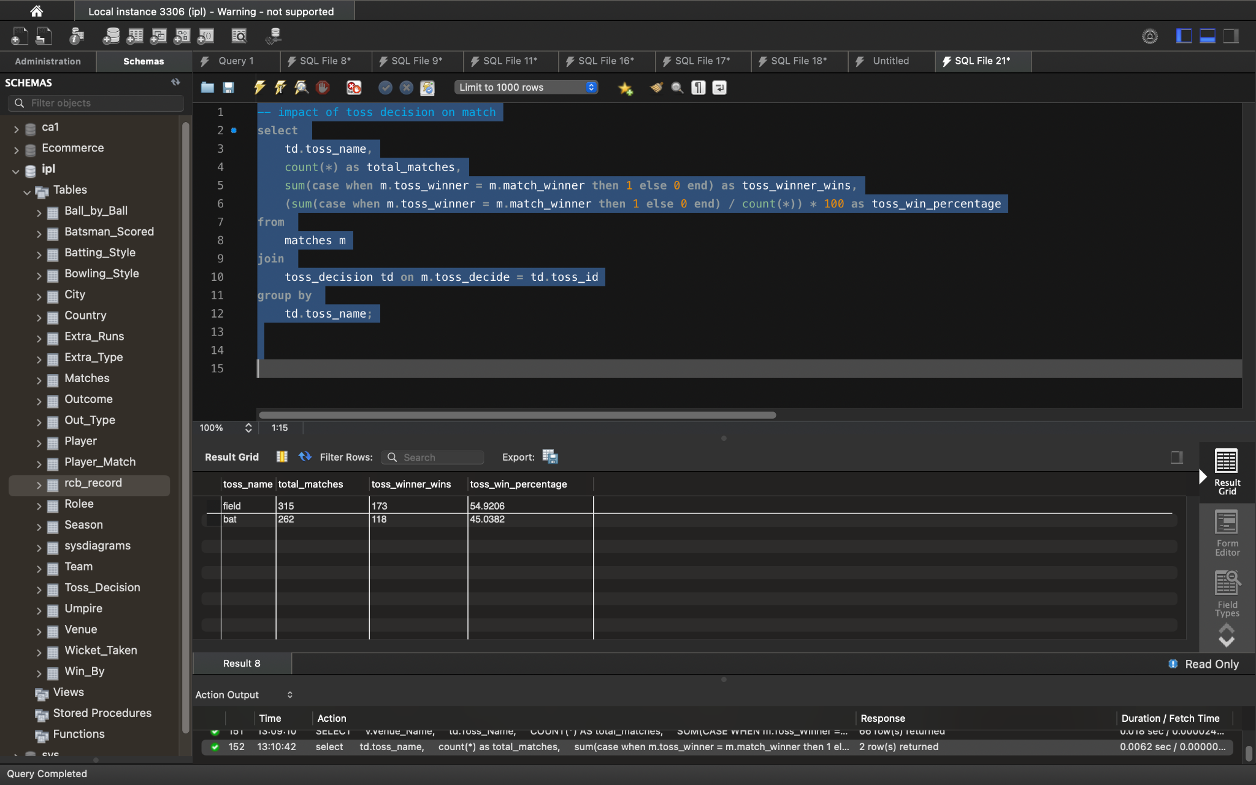

**For visualization used Stacked Bar Chart**

* X-axis: Toss Decision (Bat or Field)
* Y-axis: Count of Matches
* Stacked bars representing Toss Winner Wins and Toss Winner Losses for each Toss Decision
* This chart will give a quick visual comparison of the win percentages for teams choosing to bat or field first

**Q2) Suggest some of the players who would be best fit for the team?**

Ans) top batsman

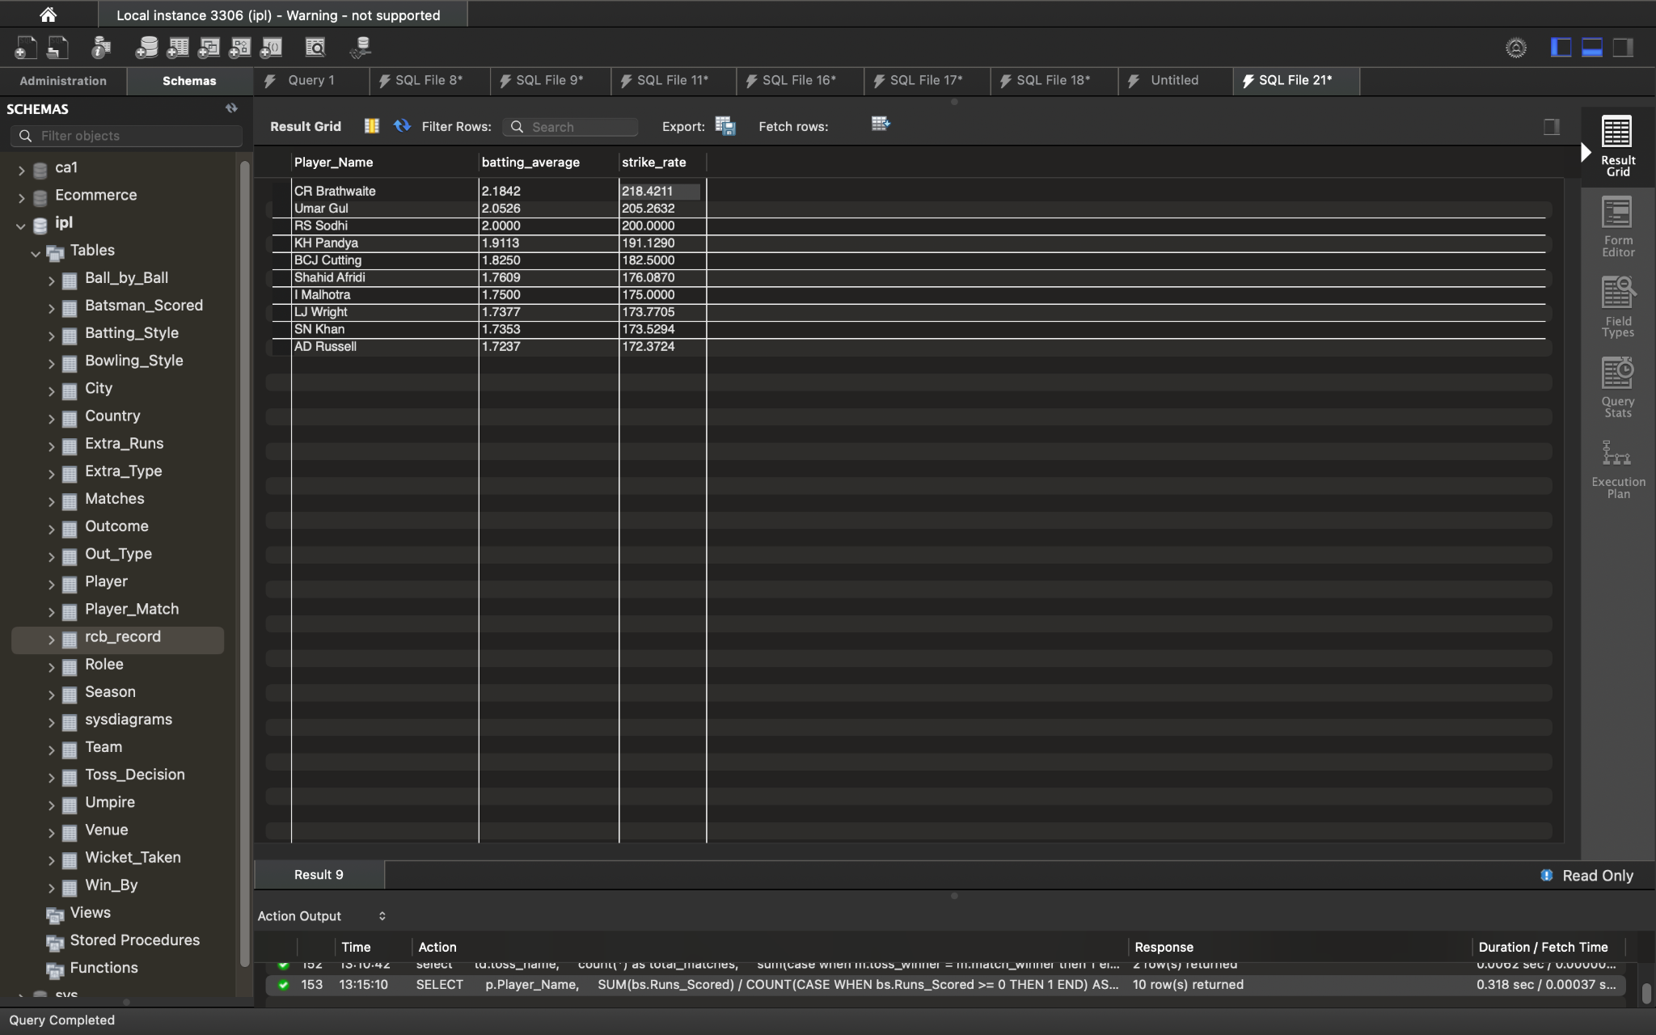

Top bowlers

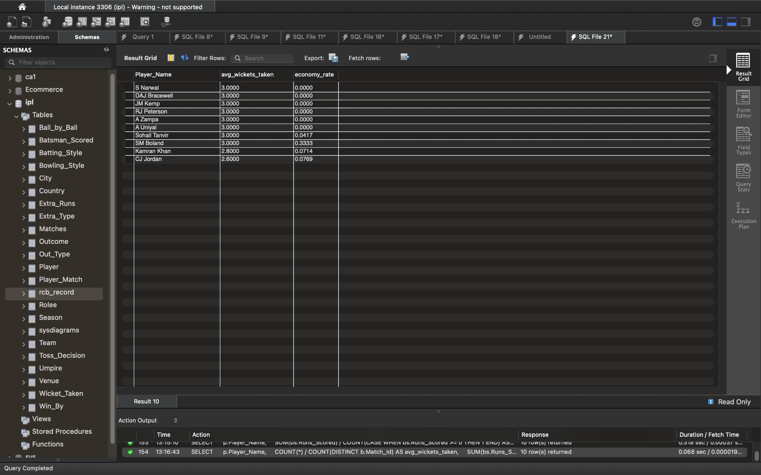

**Q3) What are some parameters that should be focused while selecting the players?**

Ans) **Performance Metrics:**

* **Batting:**
  + **Batting Average:** A good indicator of a batsman's consistency. Higher averages are generally preferred.
  + **Strike Rate:** Reflects a batsman's ability to score quickly. Crucial for T20 cricket.
  + **Runs Scored:** The total number of runs scored by a batsman. Useful for identifying high-impact players.
  + **Boundary Hitting Ability:** The ability to hit fours and sixes, especially in crucial situations.
  + **Consistency Across Formats & Conditions:** Performance across different pitch conditions and match situations
* **Bowling:**
  + **Bowling Average:** Indicates how many runs a bowler concedes per wicket taken. Lower averages are desirable.
  + **Economy Rate:** The average number of runs conceded per over. Crucial for controlling the opposition's scoring rate.
  + **Strike Rate:** The average number of balls bowled per wicket taken. Lower strike rates indicate more frequent wicket-taking ability.
  + **Wickets Taken:** The total number of wickets taken by a bowler.
  + **Variations & Ability to bowl in death overs:** Bowlers with a good variety of deliveries and ability to perform under pressure are highly valued
* **Fielding:**
  + **Catching & Fielding Ability:** Safe hands and agility in the field can save crucial runs and create wicket-taking opportunities.
  + **Throwing Arm:** A strong and accurate throwing arm can be helpful in effecting run-outs.

**Other Factors:**

**Fitness & Injury Record:** Players with good fitness levels and a low injury history are less likely to miss matches and can contribute consistently throughout the season.

**Experience:** Experienced players can bring valuable leadership and composure to the team, especially in high-pressure situations.

**Adaptability & Versatility:** Players who can adapt to different roles or batting positions and contribute in multiple aspects of the game (e.g., batting and bowling) provide flexibility to the team composition.

**Team Dynamics:** Consider how a player might fit into the team culture and their ability to gel with the existing squad.

**Leadership Potential:** Identify players who can potentially take on leadership roles within the team in the future.

**Domestic & International Performance:** Consider a player's recent form and performances in domestic and international cricket.

**Auction Value & Salary Cap:** While selecting players, it's important to be mindful of the auction dynamics and the team's salary cap constraints

**Q4) Which players offer versatility in their skills and can contribute effectively with both bat and ball? (can you visualize the data for the same) ?**

Ans) We can use scatter plots for visualization as shown below

**X-axis:** Batting Average

**Y-axis:** Bowling Average

**Each point:** Represents a player

**Tooltip:** Can show the player's name and their exact batting and bowling averages when hovering over the point

**Q5) Are there players whose presence positively influences the morale and performance of the team? (justify your answer using visualization)**

Ans) we can use bar charts for the visualization.This will clearly show which players have a win percentage significantly higher than the team's overall win percentage, suggesting a positive influence on team performance and potentially morale.

**Q6) What would you suggest to RCB before going to the mega auction ?**

Ans) Suggesstions:-

1. **Identify core players**:Analyze past performance data to identify a core group of players who have consistently performed well and embody the team's spirit.
2. **Address Key Weaknesses:** Based on your analysis, pinpoint specific areas where the team has struggled in the past.
3. **Leadership & Mentorship:** Look for players who can not only contribute on the field but also provide leadership and mentorship to the younger players.
4. **Home Ground Advantage:** Consider the conditions at RCB's home ground and target players who are well-suited to those conditions.
5. **Auction Strategy:** Develop a clear auction strategy, considering the budget constraints and the priority of different player roles.

**Q7) What do you think could be the factors contributing to the high-scoring matches and the impact on viewership and team strategies ?**

Ans) Factors Contributing to High-Scoring Matches

**Batting-Friendly Pitches:** Pitches that offer true bounce, minimal seam movement, and are conducive to stroke play encourage batsmen to play aggressively, leading to higher scores.

**Smaller Grounds & Shorter Boundaries:** Smaller grounds with shorter boundaries make it easier for batsmen to clear the ropes, resulting in more sixes.

**Quality of Batsmen:** The presence of world-class batsmen with exceptional skills boost scoring rates.

Impact on Viewership

**Attracting Casual Fans:** scores can draw in casual fans who might not follow cricket regularly, leading to increased viewership numbers.

**Social Media Buzz:** High-scoring matches generate significant buzz on social media platforms, and attract new viewers.

**Sponsorship and Advertising Opportunities:** Higher viewership translates to greater exposure for sponsors and advertisers, making high-scoring matches more attractive for commercial partnerships.

Impact on Team Strategies

Batting First Strategies:teams batting first might aim for even higher scores.

Bowling Strategies:Bowlers need to adapt their strategies to contain the flow of runs on batting-friendly pitches.

**Q8) Analyze the impact of home ground advantage on team performance and identify strategies to maximize this advantage for RCB ?**

Ans) Understanding Home Ground Advantage:

**Familiarity with Pitch and Conditions:** Teams are more accustomed to the specific characteristics of their home pitch, such as bounce, pace, and turn. This knowledge allows them to tailor their team selection and strategies accordingly.

**Crowd Support:** The passionate support from home fans can boost the morale of the home team and create a daunting atmosphere for the visiting team.

**Travel and Fatigue:** The visiting team might experience fatigue due to travel and adapting to a new environment, while the home team enjoys the comforts of their familiar surroundings.

Strategies to Maximize Home Advantage for RCB

**Pitch Preparation:**

If the analysis reveals that RCB performs better on spin-friendly pitches at home, prepare the pitch accordingly

**Team Selection:**

Select players who are well-suited to the home conditions. For example, pick more spinners if the pitch favors spin.

**Q9) Come up with a visual and analytical analysis with the RCB past seasons performance and potential reasons for them not winning a trophy ?**

Ans) We'll analyze RCB's performance in the following aspects:

**Overall Win-Loss Record**

We'll calculate RCB's overall win percentage across all seasons and compare it to the average win percentage of all teams and the win percentage of teams that have won the IPL.

**Season-wise Performance Trends**

We'll track RCB's win percentage, runs scored per match, and wickets taken per match across different seasons to visualize any trends or patterns.

**Performance in Crucial Matches**

We'll analyze RCB's performance in playoff and final matches to see if they struggle under pressure.

Potential Reasons for Not Winning a Trophy

1,Inconsistent Performance

2,Underperformance in Crucial Matches

3,Batting or Bowling Weaknesses

**Q10) How would you approach this problem, if the objective and subjective questions weren't given?**

Ans) If the objective and subjective questions were not provided, I would approach the IPL dataset analysis with a focus on exploratory data analysis (EDA).

Here's a breakdown of my approach:

**Data Understanding and Exploration**

Schema Analysis: I'd begin by thoroughly examining the database schema to understand the available tables, their columns, data types, and relationships.

**Data Profiling:**

Calculate summary statistics (count, min, max, average, etc.) for numeric columns

Check for missing values and outliers

**Identify Potential Areas of Interest**

**Player Performance:**

Top-performing batsmen and bowlers across various metrics

Consistency of player performance over time and across different conditions

**Team Performance:**

Overall win-loss records and trends for different teams

Season-wise performance variations

**Data Analysis & Visualization**

Bar Charts: To compare team or player statistics across different categories

Line Charts: To track trends in performance over time or across different phases of a match

Scatter Plots: To explore relationships between two variables (e.g., batting average vs. strike rate)

Heatmaps: To visualize performance across multiple dimensions (e.g., player performance by venue)

**Q11) In the "Match" table, some entries in the "Opponent_Team" column are incorrectly spelled as "Delhi_Capitals" instead of "Delhi_Daredevils". Write an SQL query to replace all occurrences of "Delhi_Capitals" with "Delhi_Daredevils"?**

Ans) update matches

set opponent_team = 'delhi daredevils'

where opponent_team = 'delhi_capitals';